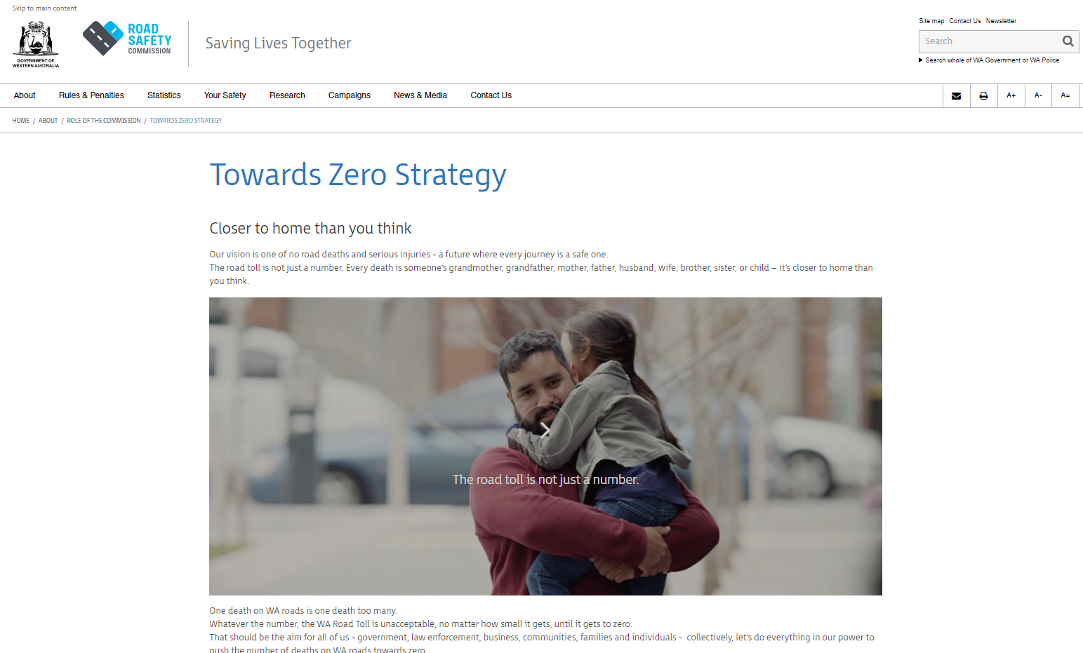

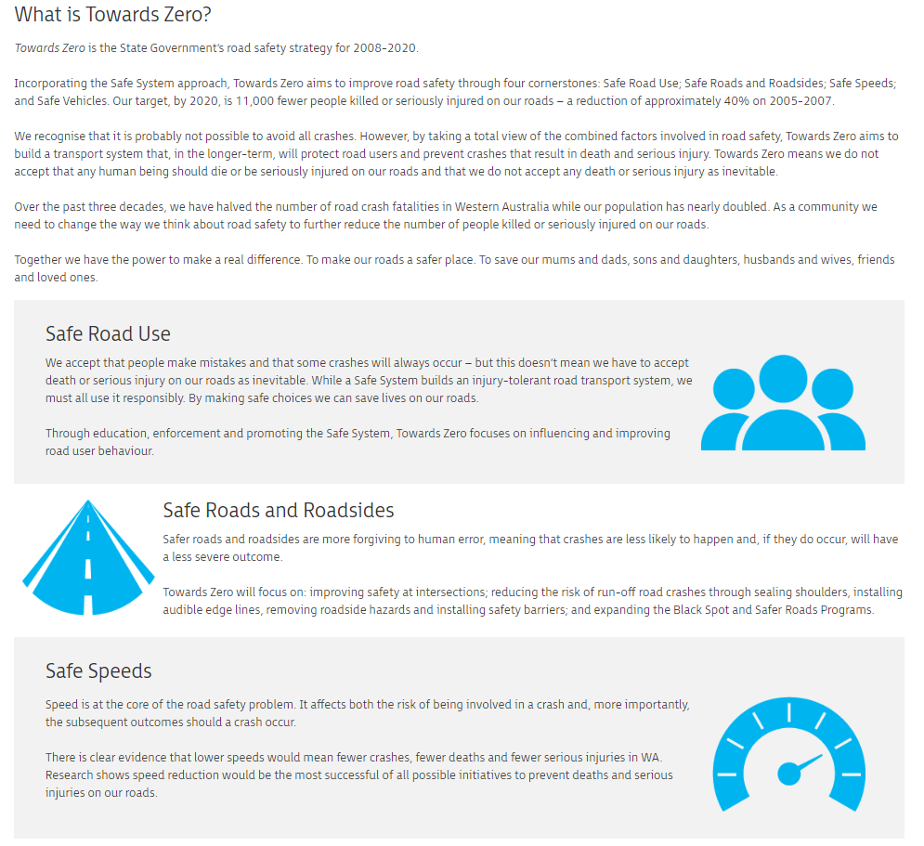

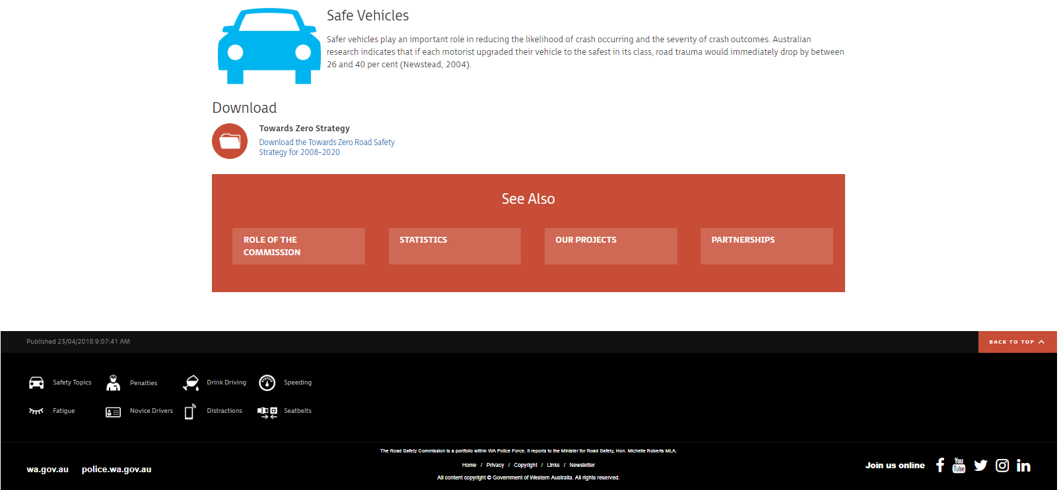

Government of Western Australia. (2019). Road Safety Commission. Retrieved from: https://www.rsc.wa.gov.au/About/Role-of-the-Commission/Towards-Zero-Strategy

